The 2020 Children’s Christmas Shop
Celebrating two traditions of merry cheer and smiling faces
Please come and support IHM school!!
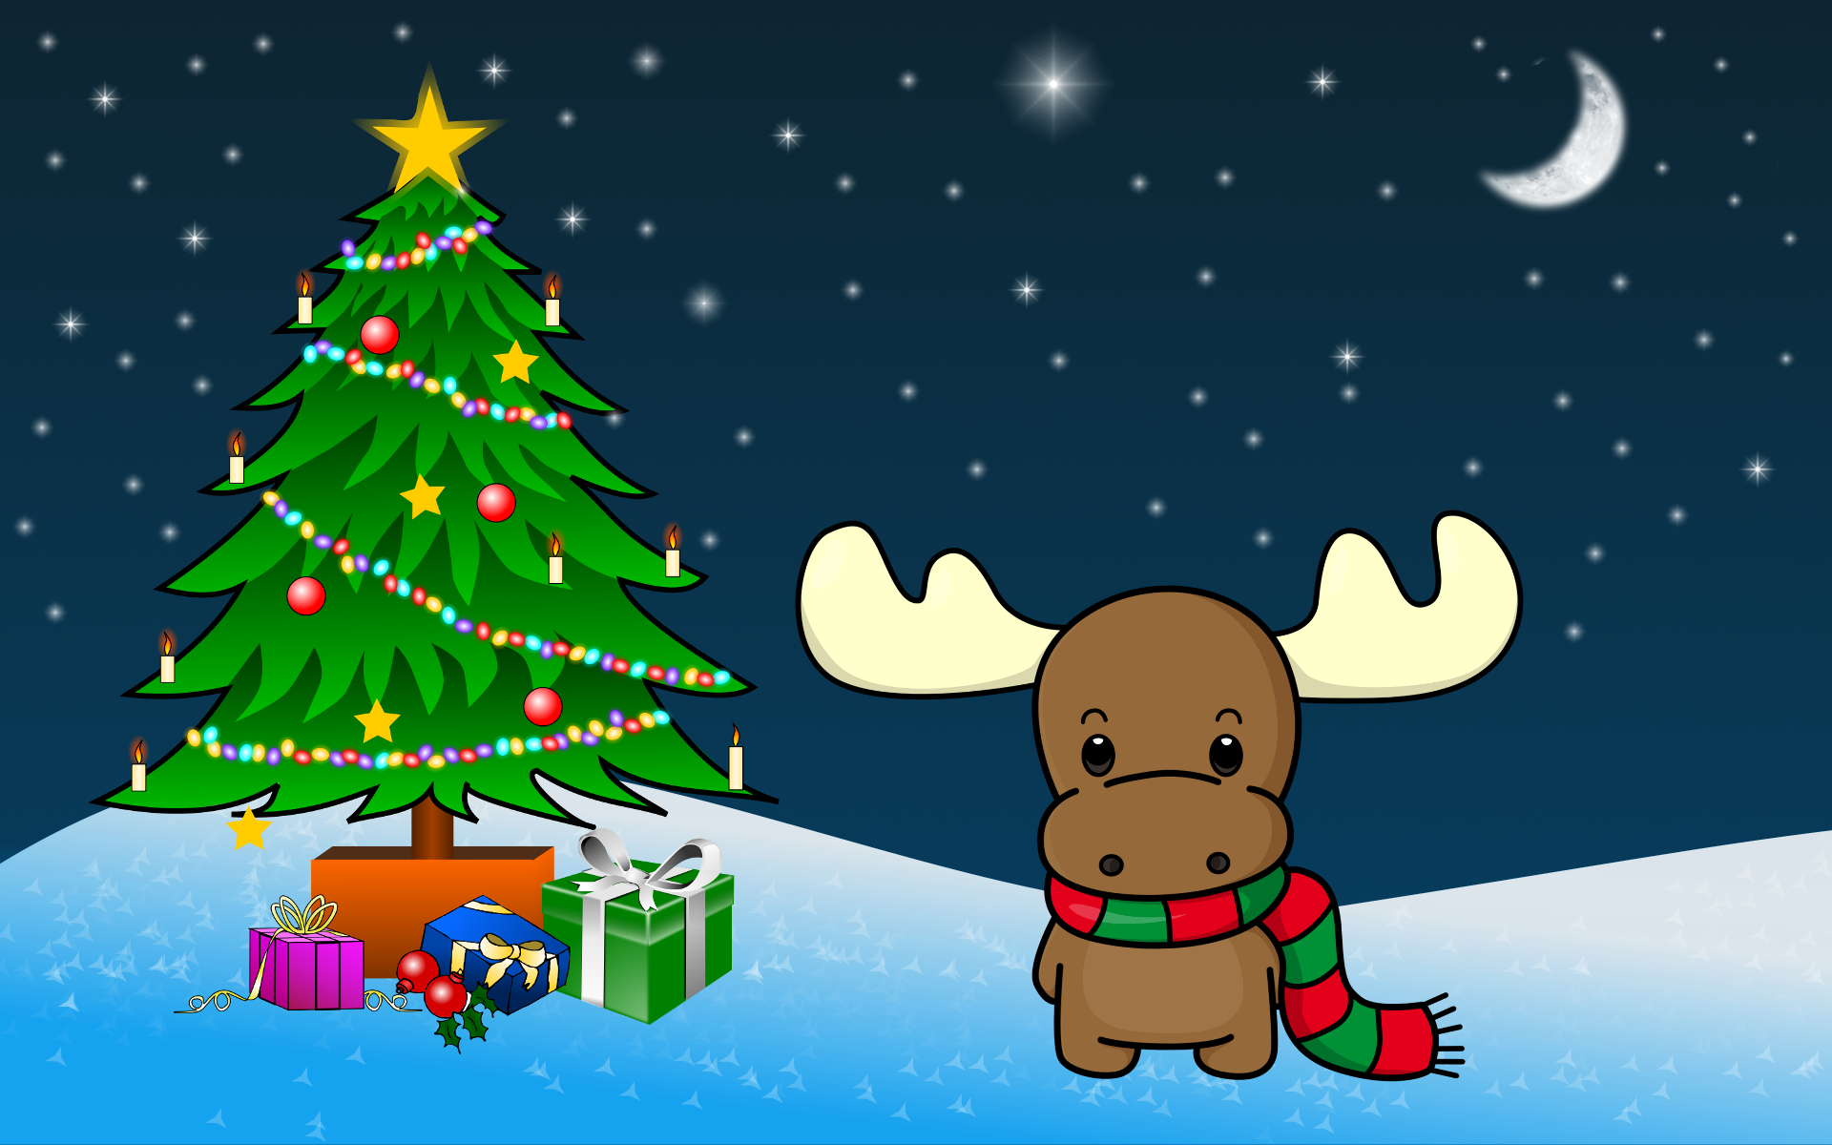
Will be held at:
St. Mary’s Carnevale Center
10 Lenox Ave., Pompton Lakes
December 6th & 13th from 9:00 a.m.-3:00 p.m
Checks and credits cards only, no cash please

The Christmas shop may look different this year, but IHM School is joining efforts with the St. Mary’s Parish to ensure our children still have an opportunity to buy holiday gifts for family, friends, teachers, etc.

We welcome the children and families of both former SMS and IHM schools.
Masks are required at all times, gloves optional

Temp checks will be given prior to entry, along with signed Covid Waiver forms and sign-in sheet

Please consider one parent/adult shop with a child(ren) when possible. Children who can shop alone will have assistance to shop with volunteers, please let us know at door.

Additional details on the Facebook page:
2020 Children’s Christmas Shoppe
www.facebook.com/groups/2020childrenchristmasshoppe/

We graciously thank Father Frank, Keith Orotosky, Father Mat, and Principal Monte for their support with this opportunity for our kids.

